Project: Shah Sachal Sami aein USAID Jo pegam: “Karyo Ilam Khe Aam”

By Small Grants and Ambassador’s Fund Program, USAID Pakistan Implemented by Shah Sachal Sami Foundation, Nawabshah
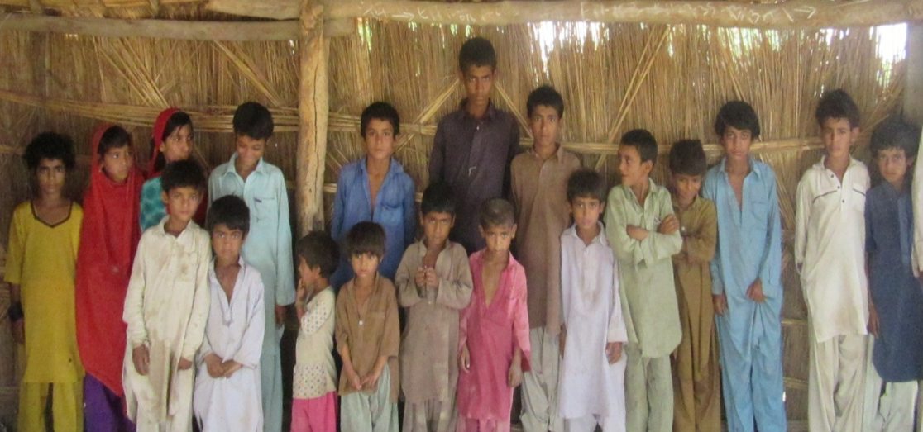
SUCCESS STORY – PATH OF LIGHT

Village Jeand Laghari is situated in UC Sawari Taluka Qazi Ahmed District Shaheed Banizrabad, where more than 12 households are settled, with 210 populations. Though some of children of the village were enrolled in GBPS Wali Muhammad Merasi, most of the residents of the village were illiterate with large number of children were out of school and were engaged in supporting their parents in agricultural and livestock activities.

Ilm-Ambassadors namely Javeed Ali Dahari and Ghulam Fareed Dahari from village Nabi Bux Dahari, having obtained 1-Day capacity building training assigned to work in the village Jeand Laghari as large number of children was out of school. Both the Ilm-Ambassadors visited the village and conducted meetings with the community influential Lemon Lagahri and Ajab Laghari so as to inspire their backing amid at enrolling the out of school children in GBPS Nabi Bux Dahri. Having won their support, community meetings were held with the villagers and consequently some of the villagers were induced so much so that they expressed readiness to provide information about their children and get them enrolled in the school.

However, enrollment of girls remained a locked-door. In this connection, female Ilm Ambassadors Malookan visited households with out of school girls and conducted meeting with the parents for the enrolment of their girls. Fortunately she was able to forge a way out and as a result 9 girls and 12 boys aging 5-15 had been enrolled in GGPS Nabi Bux Dahari and GBPS Nabi Bux Dahari respectively and had been attending the school regularly.

Thanks to efforts of Ilm-Ambassadors under the project Shah Sachal Sami aein USAID jo pegam “Karyo Ilam Khe Aam” now majority of the children of village were studying in the school.

Villagers shared, “they are very happy that their children are putted on the path of light and they will keep them on it as long they could manage.

The project has been funded by the American people through the U.S. Agency for International Development under the Small Grants and Ambassador's Fund Program.




